- Purpose
  - The purpose of this document is to describe the procedure for drilling the dimple into the shaft of the down pressure switch.
- Scope
  - This SOP applies to all equipment assembly team members. The process applies to the following machine ID’s:
EP50317EQS0600BE1200 – Standard Controls/BDI Assembly
EP50318EQS0600BE1200 – Standard Controls/Bluetooth BDI Assembly

- Responsibilities
  - The operations manager/supervisor is responsible for enforcing this SOP.
- Materials
  - Drill press
- Definitions

- Procedure
  - Locate the sample switch. Place it into the drill fixture as shown. Use this to set the location of the fixture and the depth of the drill point. Use a 1/8” drill bit. Set the stop collar on the press.
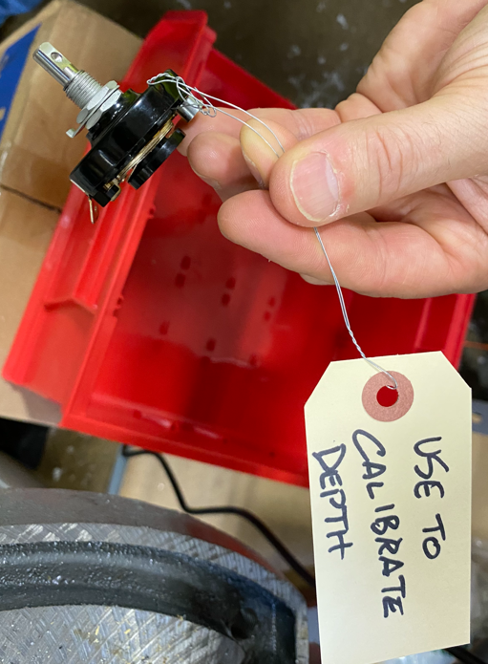

  - Once it is set. Clamp the fixture down and set the collar on the drill for the depth.
  - Drill out the appropriate number of the switches.
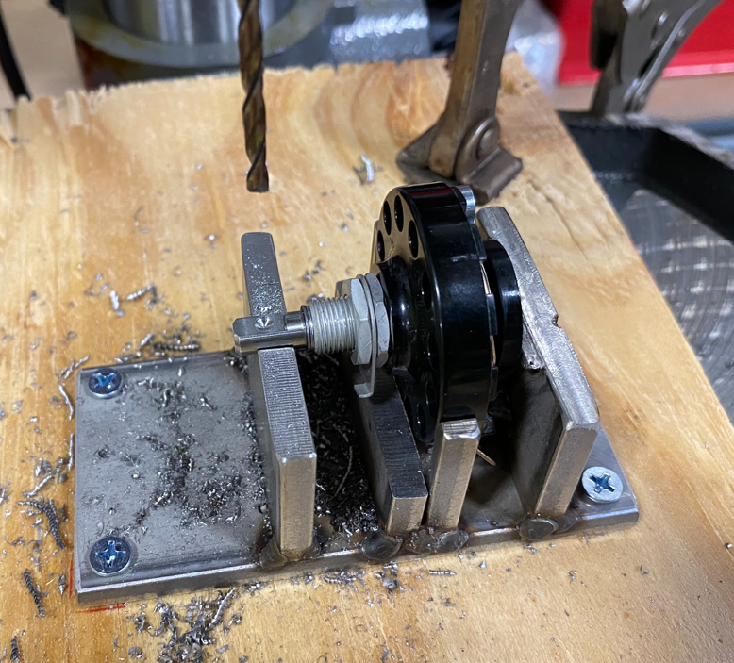
- References (optional section as needed)

- Training Guide

Functional Training Groups Requiring Training
Equipment Assembly Group

- SOP Change Control

Date of Change | Reason for Change
Rev 01 | This is the first version of the S.O.P. hence there are no revisions to this document.
Rev 02 - 4/2/2025 | Combined MSAS and G20 instructions.

Approvals

Submitter/Author Approval:__________________________________ Date:______________________

Management Approval:______________________________________ Date:______________________

QAU Approval:_____________________________________________ Date:______________________

